**Class Exercise – 6.2**

**Name: Patrick Woodrum**

**Clemson ID: C79975506**

**Submission**: Save this Word document with your answers as a PDF file and upload the PDF file to Canvas.

**Area Transit Authority**

The Area Transit Authority (ATA) is a rural public transportation company. ATA operates a fleet of 25 buses that serve approximately 1,000 riders each day. The bus operation involves 10 regular routes, plus routes for special events. The ATA employs 20 full-time drivers and 10 to 15 part-time drivers. A dispatcher coordinates the staffing and routes and relays messages to drivers regarding traffic information and special passenger pick-up arrangements.

Use one of the diagramming tools identified on the “External Tools Page” in Canvas.   
You’ll need such a tool for this chapter’s case study.

**Tasks**

1. Identify possible actors involved in ATA’s bus operations.

**Rider, Full-time driver, part-time driver, Dispatcher**

1. Create a use case diagram for the bus system using the actors identified above.

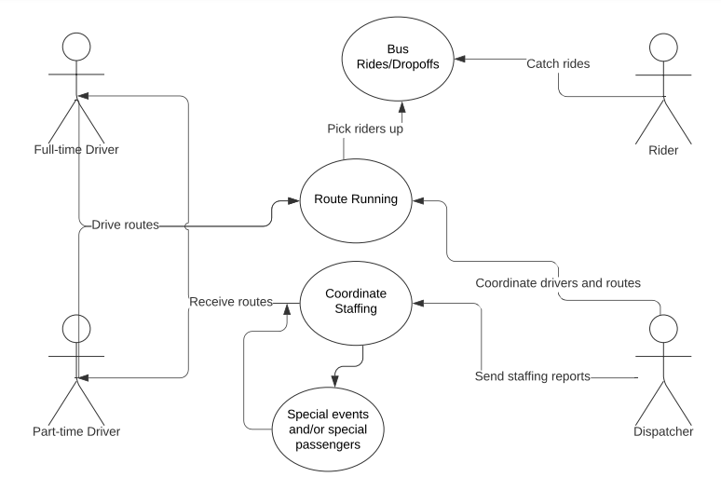

1. BONUS: Create a state transition diagram that describes typical passenger states and how they change based on specific actions and events.